Prepare new file into your existing app

* Right click on app new file
* Give the name as **ChangeColorDirectives.ts**
* import { Directive, ElementRef } from "@angular/core";

@Directive({

    selector:'[changecolor]'

})

export class changeColorDirective{

    constructor(er:ElementRef){

        er.nativeElement.style.color="red";

    }

}

Register created directive in **app.module.ts** in the list of Declaration

import { NgModule } from '@angular/core';

import { BrowserModule } from '@angular/platform-browser';

import { AppRoutingModule } from './app-routing.module';

import { AppComponent } from './app.component';

import { changeColorDirective } from './changeColorDirective';

import { UserService } from './user.service';

@NgModule({

  declarations: [

    AppComponent,

    changeColorDirective

  ],

  imports: [

    BrowserModule,

    AppRoutingModule

  ],

  providers: [UserService],

  bootstrap: [AppComponent]

})

export class AppModule { }

goto to **app.component.html**

<h1>Demo App</h1>

<h2 changecolor> Hello World</h2>

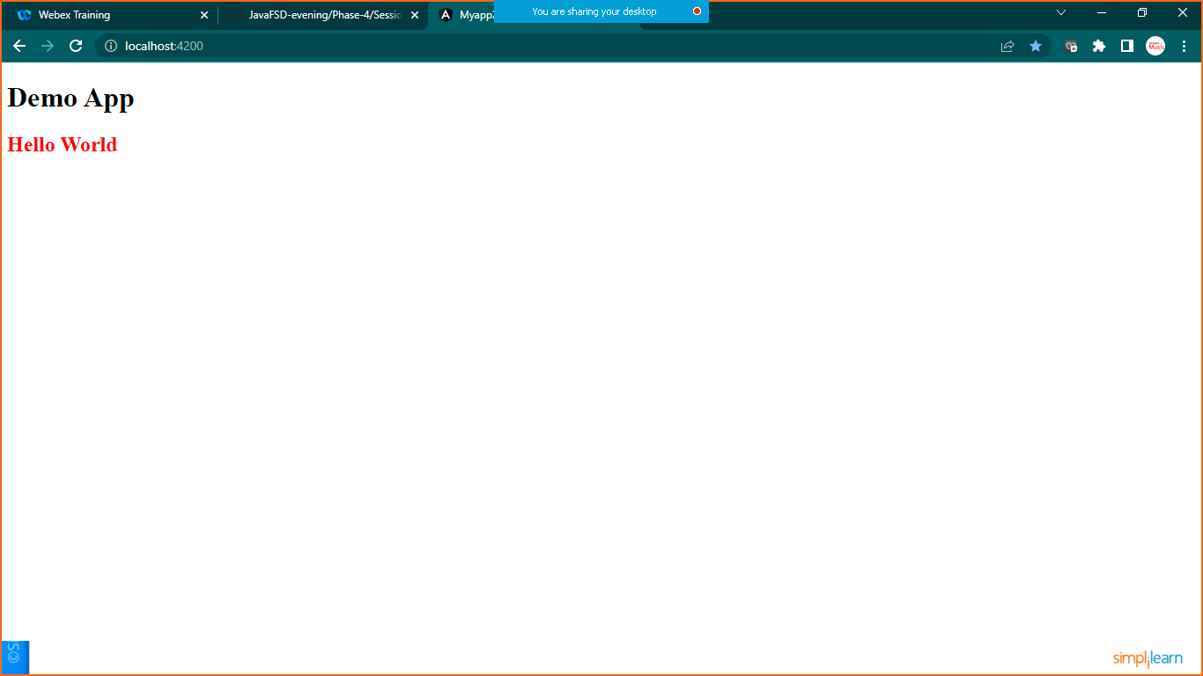

**Another way of using Renderer and ElementRef**

**Create another file name HighlightDirectives.ts**

import { Directive, ElementRef, Renderer2 } from "@angular/core";

@Directive({selector:'[highlight]'})

export class HighlightDirective {

    constructor(er:ElementRef,render:Renderer2){

        render.setStyle(er.nativeElement,'background-color','green')

    }

}

**Register this in to app.module.ts**

import { NgModule } from '@angular/core';

import { BrowserModule } from '@angular/platform-browser';

import { AppRoutingModule } from './app-routing.module';

import { AppComponent } from './app.component';

import { changeColorDirective } from './changeColorDirective';

import { HighlightDirective } from './HighlightDirectives';

import { UserService } from './user.service';

@NgModule({

  declarations: [

    AppComponent,

    changeColorDirective,

    HighlightDirective,

  ],

  imports: [

    BrowserModule,

    AppRoutingModule

  ],

  providers: [UserService],

  bootstrap: [AppComponent]

})

export class AppModule { }

**now goto> app.component.html**

**add the below code**

<h1>Demo App</h1>

<h2 changecolor> Hello World</h2>

<h3 highlight> Hello</h3>